SEASON: 2023
NSW Team Yarding & Sorting Basic Rules

A team consists of three riders.

The announcer is to advise the collar colour drawn for the run. As the first competitor’s horse’s nose crosses the start line the clock will commence. A team has 10 seconds to cross the start line, after the colour has been indicated, before the clock will start automatically.

Within a ninety second time limit a team must cut from the mob and yard three head of cattle with the same assigned colour. A warning bell is to be rung at 60 seconds and the end of the run will be signalled by a whistle.

The centre line is positioned approximately in the centre area of the arena. All cattle must be on the mob side of the line and horses on the other before time begins.

Time is automatically called when the rump of the last beast passes the plane of the gate. The rider’s horse must not enter the yard any further than the pommel of the saddle. Entering further than the saddle will result in a no time.

A team may call time with, two or three cattle yarded. Teams with three cattle will be placed higher than those with two. Juniors have the option to pen three, two or one head of cattle.

Time cannot be given until the assigned cattle are in the yard and all other cattle are behind the centre line. All riders must be on the yard side when calling time.

No time will be given if incorrect cattle are in the yard when time is called.

Any more than five head of cattle across the starting line at any time incurs a no time.

No whips or slapping with reins to be used on horses or cattle. No fixed headsets (head checks) allowed on horses during competition, rings are allowed with split reins only.
A short riding crop maybe used by inexperienced junior riders only at judges discretion.

The judge has the right to disqualify any competitor in breach of the rules.

Once the team of riders have secured 3 marked head of cattle over the centre line they must not allow stock to return back over the centre line to the mob. Riders may cross the centre line freely to block however once a steer is lost over the line it cannot be reclaimed.

In effect once you have had a chance at yarding your cattle and loose them you cannot go back for a second chance even if time remains.

If one or two head crosses the centre line back to the mob the team may only yard the cattle that remain at the yard end of the centre line.

Junior riders may yard 1 or 2 marked head of cattle and the remainder any other head of cattle.

GENERAL RULES
- Within a 90-second time limit, a team must separate from the herd and pen three head of cattle with the same assigned collar. A warning bell will be given to the team working the cattle at 30 seconds prior to a final time being called by a whistle. In the event a warning is not given, a rerun may be offered by the judge. This rerun will be given immediately after the cattle are settled. A whistle blow will indicate full time and all riders are to cease yarding.

- It is suggested that no tag or clean skin cattle be drawn by a black marker.
- There must be a minimum of 18 to a maximum of 24 head of cattle in the mob. In the event more or less than three assigned cattle are discovered within the herd, the team(s) with more or less than three assigned cattle must have a rerun. Time for all other teams within such a miss-marked herd will remain the same. In the event a colour is called twice in the same herd, a rerun may be given to the second team drawing that colour.
- If a collar has come off in a mob containing clean skins, neither the collar colour nor clean skins may be drawn in that round.
- All cattle will be settled on the cattle side of the starting line before time begins. The judge will indicate when the arena is ready. Riders will be given their assigned colour and given 10 seconds to begin their run after which the clock starts automatically. Time begins when the nose of the first rider’s horse crosses the starting line.
- Yarded cattle are to be moved back to the herd after a run is finished. It is the next team’s responsibility to make sure the herd is settled and unified.
- Reruns will be given for "Mechanical Failure or Management Error." If an animal is sick or injured, or if any extraneous animals such as dogs enter the arena, it will be the judge’s decision whether or not to grant a rerun.

COMMENT: Management should make sure all cattle are healthy, two eyed, and workable. Even so, an animal may occasionally be hurt during the contest, or a wild one may jump out. Therefore, the above rule is important. Exceptionally wild cattle should be eliminated before the contest. Injured cattle are to be removed immediately after a run and replaced.

- To call time no part of the yarded cattle can be over the plane of the gate. Any head penetrating the plane of the gate will be considered as not yarded. The rider must not enter the plane of the gate any further than the pommel of the saddle. All unassigned cattle must be completely on the herd side of the cattle line or the team will be judged a no time. If a team calls for time with only two of their cattle in the yard, the remainder of their assigned cattle must be on the herd side of the cattle line.
All riders must be mounted and on the yard side of the arena when time is called.
- A team calling for time with any wrong marked cattle in the pen will be judged a no time.
- A steer judged as yarded must be completely in the yard.
- If more than five (5) head of cattle are across the cattle line at one time, the team will be given a no time. Cattle will be judged over the cattle line when all four feet are over the line.

- Times and cattle yarded by all participants will be recorded for every run.

- It will be the committee’s decision in the event of a tie, a run-off will decide the winner.

- Herds of cattle will be changed depending upon the number of cattle in the mob i.e. 21 cattle in the mob; mob changed every seven (7) runs. When a mob of cattle is removed from the arena for any reason at all, a new pen of cattle will replace them.
- Outside help for riders will result in disqualification.
- The fall of a horse and/or rider shall not eliminate the entry; however, any attempt by a dismounted rider to work cattle before mounting will result in an automatic disqualification.
- Contact with or hazing cattle with hats, reins, or any other equipment or apparatus is disqualification.
- Inexperienced junior riders only are allowed to use riding crops. Excessive use of crops won’t be tolerated. This is at judges discretion.
- NO alcohol is to be consumed whilst on horseback.
- NO smoking while in the arena.
- Dogs are allowed at the events but MUST be contained on a leash at all times. The announcer is to announce this at the beginning of each event.
- If, in the opinion of the judge, unnecessary roughness occurs, the judge will stop the run at the point of infraction and the team will be given a disqualification.
- Unnecessary roughness which will result in disqualification are:

      - Jumping cattle or making them leave the arena.
      - Intentional contact with the cattle by hazing.
      - Rider making a cow push into the arena fence.
      - Cattle bumping at the entrance to the pen.
      - Pushing cattle into the back panel of the pen.
      - Any horse abuse

- Unsportsmanlike conduct by a team and/or rider will result in disqualification. Unsportsmanlike conduct is defined as abuse of one’s horse or cattle, use of foul language and disrespect towards the judge or any other competitor, intoxication in the arena or on the grounds or any other conduct felt to be detrimental to the sport of team yarding.

- Decisions of the judge are final. Penalties and reruns given by the judge will be announced. Any questions or disputes must be directed to the rider representatives on the day. The rider representative does not settle the dispute but is merely a go-between for the judge and the riders and may offer advice and discuss the rules.

- Once the team of riders have secured 3 marked head of cattle over the centre line they must not allow stock to return back over the centre line to the mob. Riders may cross the centre line freely to block however once a steer is lost over the line it cannot be reclaimed. In effect once you have had a chance at yarding your cattle and loose them you cannot go back for a second chance event if time remains.
If one head crosses the centre line back to the mob the team may only yard the cattle that remain at the yard end of the centre line.

- Junior riders may yard 1 or 2 marked head of cattle on judges request and the remainder any other head of cattle, once juniors have their allocated 3 head over the line they will be given a time on that 1,2or 3 head yarded.

  - Junior safety rider - A safety rider is to be present for each junior run. Their role is to maintain safety and intervene when support is required. The safety rider in consultation with the judge may rule if a rider is not proficient enough to participate safely.

  - No riders under the age of 18 may ride a stallion.

- Fill in Riders - Any rider can fill in a position for another team but must do so under the following conditions.

Teams requiring a fill in rider must organise with the committee prior to competition beginning fill in riders. The committee may have fill in riders available. If the committee does not, it is the teams responsibility to find fill in riders

  - Teams must notify the judge before starting their run of the fill in rider.
  - No points are awarded to fill in riders for their fill in run.
  - The Judge must ensure that an NP (No Points) is marked on the judges sheets against the rider’s name. This must be done prior to the run.
  - No one rider can fill in any more than 1 time on top of their own runs at any one event.
  - The committee reserves the right to pay prize money for fill in rides. It is recommended however that if the rider pays for the run then they are eligible for prize money and no points.
- Reruns – may be given under the following circumstances
    - Miss-marked Cattle. As each new team begins a run, there should be the same allocated number of cattle in the arena. In the event that more or less than three identical marked head are in the arena and is the colour given the team riding, a rerun must be given. Times for all other teams within such a miss-marked herd will remain the same.
    - Duplicate Collar. In the event a team is given a colour that has already been used within a given herd, a rerun may be given.
    - Escaping Animal. If an animal leaves the arena either through or over the fence, the team can either be disqualified for unnecessary roughness, or be given a rerun depending on the judge's decision.
    - Riders Commitment to Cattle. Once committed to the cattle, a team is completely responsible for their animals. It is the team's responsibility before working the cattle to pull up and call for a judge if, in their opinion, there is an injured animal in their marked cattle. Depending on results of inspection of the animal, it will be the judge's discretion whether the team's decision to pull up will result in a rerun or disqualification.
    - Mechanical / Official Errors. In the event of mechanical or official error, the participating team shall get a rerun.
- Rider representatives. There is to be two rider reps at every event. If a club is running two events over a weekend there must be two sets of rider reps nominated. Rider representatives must be changed at each event.
- Protests. Protests/complaints must be addressed to the judges before leaving the arena. Rider is not to give details about the protest/complaint and then must leave the arena immediately. Details of the complaint are to be made to the rider representative, outside of the arena. The issue will be discussed between the rider representative’s and the judge. At no time is a competitor to approach the judge. All decisions made by this committee are final.
- Judge’s Box. There are to be 3 representatives in the judges box at all times and at each event. These people must be members and have a sound knowledge of the rules and of the sport.
- Judge's Decision Final. Decisions of the judges are final.
DRESS CODE
  - All contestants must wear a hat and boots and a long sleeved (recommended) buttoned shirt with a collar or jacket. Men’s or women’s long pants (jeans) are required. All contestants are encouraged to maintain an Australian country image. Boots must be recognised as riding boots with a heal.
  - Riders under the age of 18 must wear a helmet meeting the Australian standard at all times whilst on a horse.
JUDGES AFFILIATION
All Judges must be affiliated judges to judge an affiliated event.
To become an affiliated judge you are required to:
- Take a judges affiliation school (held by NSW Team Yarding & Sorting)
- Shadow judge for at least half of one event.
CATTLE IDENTIFICATION/WELFARE

There are two systems that can be used to mark the mobs.
  - Neck collars – A colour band 100mm wide attached around the neck of the beast. Each collar may have two colours.
  - Back Tape – Tape 50mm wide and 600mm long glued on with liquid nails over the withers, back and rump of the beast. The back of the beast is to be marked using two bands so no mistake is made between shoulder and rump.
Water troughs must be accessible by the cattle in the back yards throughout the competition & must be a minimum of 200L in size (eg. Bathtub). Troughs must be kept clean & full for the duration of cattle being held in yards.
It is recommended to move starting times forward in the summer months to ease stress on cattle.

JUDGES POSITION

There are two arena layouts that apply. The layout depends on access to a flag judge or not.
If there is no flag judge present then the judge must be able to see directly across the plane of the gate. The judge will be positioned on the centre line so the pen must be turned on an angle so the plane of the gate is in line with the judge. If a flag judge is present then the yard may be positioned anywhere in the diagram. 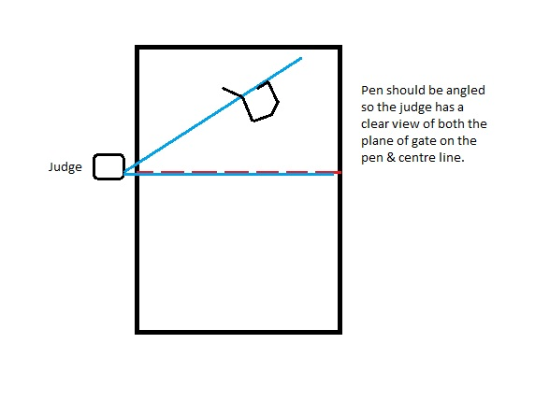
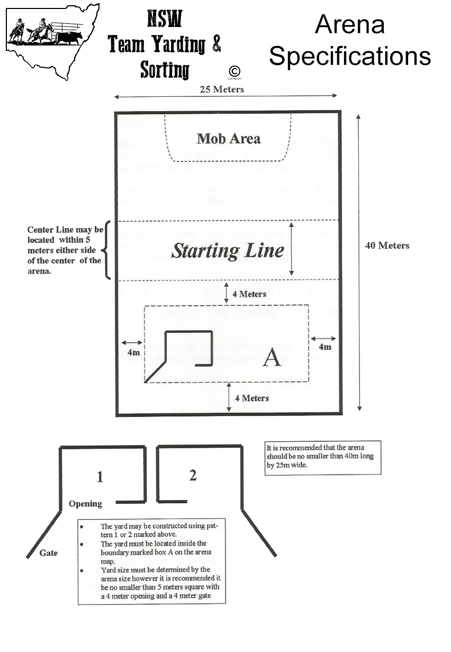
The judge may also announce over the loud speaker but must not be time keeping and recording times at the same time.

CLOCKS AND TIME
All runs have 90 seconds to complete the run. All competitors must have the same amount of time per run.

ENTRIES

- Entries. Teams are to be made up with a minimum of three riders. Teams can run with the same competitors 3 times or a combination of riders if the team contains more than 3 riders.

- The committee reserves the right to limit riders to entering either the open or junior event. This means junior riders cannot compete in both the open and junior divisions unless the committee has approved it.

- Limited or capped entries must be advertised and preference to ‘first in best dressed’

- Committees are recommended to run a minimum of 50 entries.

- Members have the right to nominate at affiliated events 24 hours prior to entries opening.

JUNIORS
Riders are eligible to compete as a junior rider if they are:-
- 16 years of age and under at their first competition event for that season. Juniors who turn 17 during that competition season may still compete as a junior.
- Considered a competent rider that is safe to work with cattle based. As a guide they must be able to handle their horse at all passes proficiently without any special rider assistance. They must be able to maintain control of their horse and be seen to ride within their capabilities.

Junior safety rider - A safety rider is to be present for each junior run. Their role is to maintain safety and intervene when support is required. The safety rider in consultation with the judge may rule if a rider is not proficient enough to participate safely.

ENTRY FEES

All entry fees must be advertised to competitors prior to entry. The organising committee reserves the right to charge whatever entry they feel appropriate to cover their financial circumstances, however $15 - $20 per person per run is recommended. $5 cattle levy may also be applied per person for the day.

RECOMMENDED PAYBACK SCHEDULE
NTY recommends that 50% of the entry fee is given back to the prize pool.

Example, 100 entries at $50/run sums to $5000 in entries. $2500 of which would be added back (AB) to the prize money pool.
Sponsored goods can be considered as part of the prize pool and can be deducted from the prize pool money. Eg chaff, trophies, saddle cloths to the value of.
RECOMMENDED PLACE SCHEDULE
The Payback Schedule pays one place for every 10 teams, up to a maximum of 5 places. Over 30 teams must pay a minimum of 3 places.
If more than $2000 is in the prize pool then 5 places must be paid.
No. of Teams | Places | Percentages
1-10 | 1 | 100
11-20 | 2 | 60-40
21-30 | 3 | 50-30-20
31-40 | 3-4 | 40-30-20-10
41-50 | 3-5 | 35-25-18-14-8

POINT SYSTEM

Each competitor that is a current member will receive 1 point for participation at each affiliated event. 1 point only regardless of how many times they enter.
Place getters are awarded extra points according to the following schedule. Competitors also receive 2 points per every pen of 3 scored.

Place | Point | Participation point | Total Points
1st | 5 | 1 | 6
2nd | 4 | 1 | 5
3rd | 3 | 1 | 4
4th | 2 | 1 | 3
5th | 1 | 1 | 2

AFFILIATION CHARGES
Affiliation with the NSW Team Yarding & Sorting is free. Affiliation includes advertising to our member base via our newsletter, a package including all paper work required with an optional computerised version (Team Yarding Pro 1.2) and inclusion for competitors to qualify towards the series championships.
A cost of 1 dollar per run is to be paid back as a trophy levy to the NSW team Yarding & Sorting. This fee is payable after the event.
Committees are required to take series entries on behalf of the NTY. Series entry forms and money are to be forwarded onto NTY.
If a committee agrees to affiliate then the entire event must be run under the NSW Team Yarding & Sorting rules and conditions. Committees must notify NSW Team Yarding & Sorting of all event details at least one month prior to their event. All time sheets must be forwarded to the NTY Office within 1 month of the completion of the event.

